**Introduction to MicroBlaze processor**

**Lab no# 11**



Spring 2022

CSE-308L Digital Systems Design lab

Submitted by: **Ashfaq Ahmad**

Registration No: **19PWCSE1795**

Class Section: **B**

“On my honor, as student of University of Engineering and Technology, I have neither given nor received unauthorized assistance on this academic work.”

Student Signature: ______________

Submitted to:

**Dr: Ma’am Madeha sheer**

**July** 24, 2022

**Department of Computer Systems Engineering**

**University of Engineering and Technology, Peshawar**

**Objective:**

* To learn how to use Xilinx MicroBlaze Microcontroller

**Introduction to MicroBlaze:**

MicroBlaze is Xilinx’s 32-bit RISC soft processor core, optimized for embedded applications on Xilinx devices. The MicroBlaze processor is easy to use and delivers the flexibility to select the combination of peripherals, memory, and interfaces as needed. The MicroBlaze soft processor core is included with the Xilinx software tools.

**Task:**

Run a simple C program “hellow world” on Sporten 6 circuit.

**Steps to follow:**

1. Import the MicroBlaze IP core in the project design.

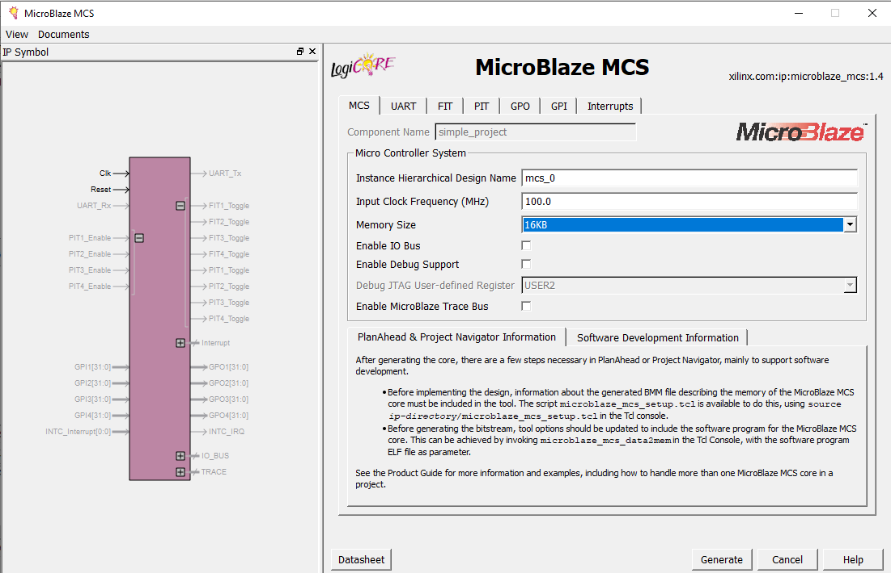

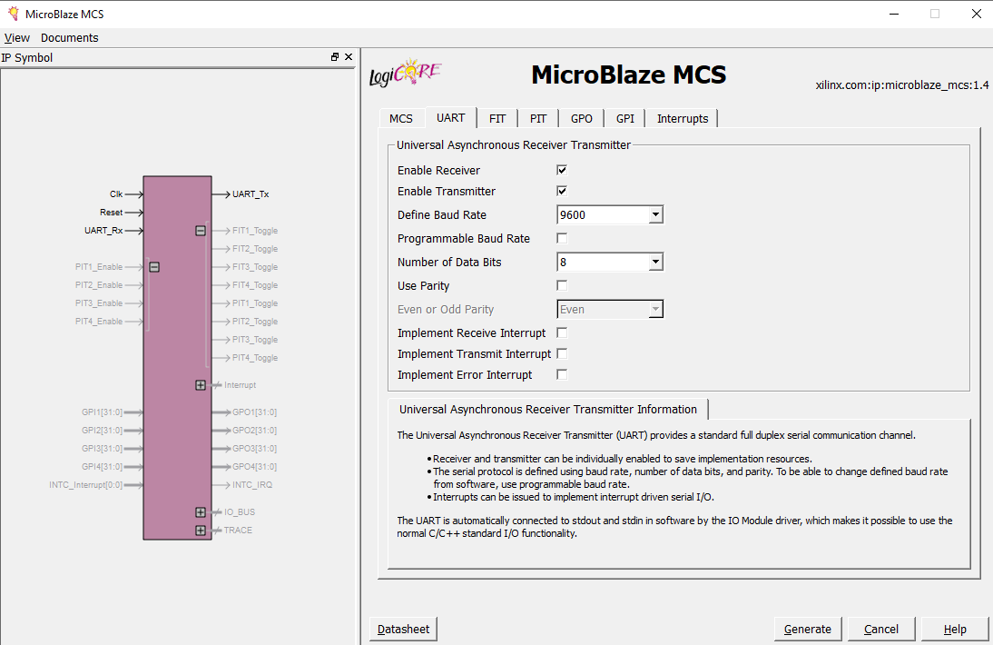

**Verilog Code and MicroBlaze instantiation:**

module hello_world(Clk,Reset,UART_Rx,UART_Tx);

input Clk,Reset,UART_Rx;

output UART_Tx;

simple_project your_instance_name (

.Clk(Clk), // input Clk

.Reset(Reset), // input Reset

.UART_Rx(UART_Rx), // input UART_Rx

.UART_Tx(UART_Tx) // output UART_Tx

);

endmodule

**C program:**

#include <stdio.h>

#include "platform.h"

int main()

{

init_platform();

while(1)

{

xil_printf("hello world %c\n");

}

return 0;

}

UCF File:

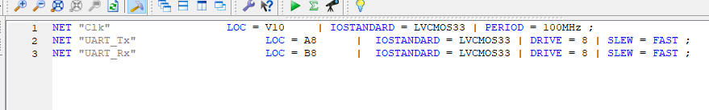

Output:

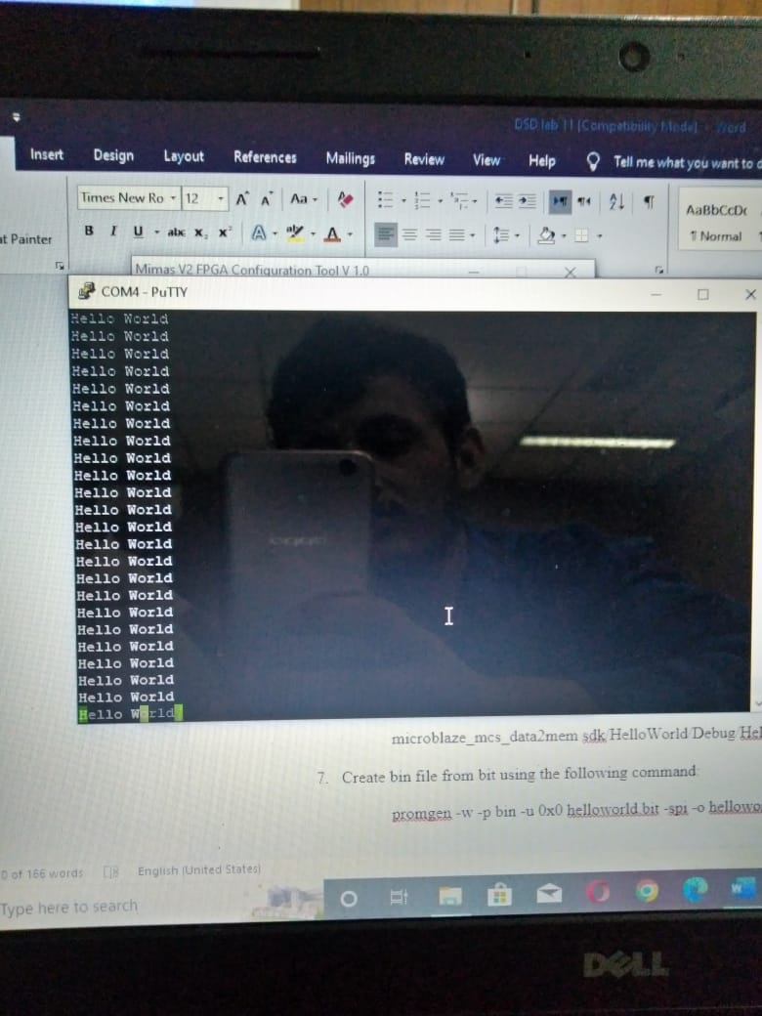

THE END